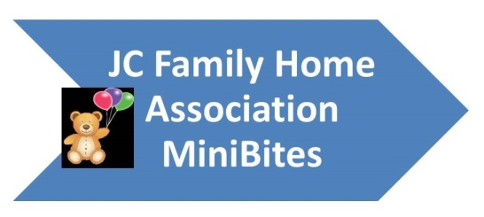
The Good News

September Volume 3 Issue 12

Renewal Packets will be on their way to you end of September and into the first part of October. Please look through these packets for information concerning the new program year starting October 1, 2018. Thank you for getting your annual enrollments in on time and if you haven't completed training yet, please check your e-mail because important online training information will be sent out to you and the class needs to be completed by September 30, 2018.

Just posted on http://www.jcfamilyhomeassociation.com/whats-new a list of Inspected processing plants in Kansas. If you raise beef or pigs and would like to use the meat that you raise, you can now do that as long as it is processed at one of these plants.

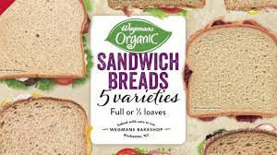
Not promoting one brand just using this graphic as an illustration! If you want to purchase organic bread you can, just know that the bread being labeled "organic" doesn't make it Whole Grain. It might be whole grain, we will have to check the label. The rule-of-three will need to be used when evaluating the ingredients to classify the product as whole grain. E-mail me pictures of labels if you have questions and we can go through them together.

UGH What paperwork do I need to have ready for Home Visits?
License, Contract Agreement, Tier Notification, Enrollments (yellow copy) or Original for newly enrolled children, Claim to include your cover sheet and menu/attendance form, infant offer form (when needed), medical statement (when needed), product analysis sheets if serving processed products, *whole grain items labels, *all cereals labels that aren't WIC to show they are under the sugar limit, and *yogurt labels.

The * indicates new items that we as home visitors are asked to monitor when we come to see you. In trying to develop a system that will make the home visits go smoother and be less intrusive for you we are asking for you to develop a notebook for these items. Those of you who are very good at phone cameras and picture taking can take pictures of the product label, be sure to have the product name and ingredient list and print those out, put them in a pocket folder or plain folder and then that can be handed to us when we are there. We feel that we are inconveniencing you when you’re busy and trying to get a meal served to the children and we want to know about your whole grain muffins you served two weeks ago. A folder that can be handed to us that has this information will help with that. You can cut out the label or save the box or take pictures, whatever works for you.

If you find that this request is overwhelming then wait till we have a chance to talk with you, we really do want to help you help us with this. Thanks
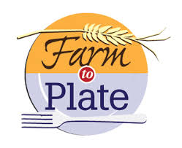
Using the Grow it Try it Like it curriculum for preschool ages you can start to do your own farm to plate program and build on it to include local food sources. We will be giving out more information soon.
https://www.fns.usda.gov/tn/grow-it

Contact Us
P.O. Box 1203 Junction City, KS 66441
785-762-2424 / Fax: 785-762-2623
Janet@jcfha.kscoxmail.com / jcfamilyhomeassociation.com

USDA Nondiscrimination Statement
In accordance with Federal civil rights law and U.S. Department of Agriculture (USDA) civil rights regulations and policies, the USDA, its Agencies, offices, and employees, and institutions participating in or administering USDA programs are prohibited from discriminating based on race, color, national origin, sex, disability, age, or reprisal or retaliation for prior civil rights activity in any program or activity conducted or funded by USDA.
Persons with disabilities who require alternative means of communication for program information (e.g. Braille, large print, audiotape, American Sign Language, etc.), should contact the Agency (State or local) where they applied for benefits. Individuals who are deaf, hard of hearing or have speech disabilities may contact USDA through the Federal Relay Service at (800) 877-8339. Additionally, program information may be made available in languages other than English.
To file a program complaint of discrimination, complete the USDA program discrimination complaint form, (AD-3027) found online at https://www.ascr.usda.gov/sites/default/files/Complain_combined_6_8_12_508_0.pdf and at any USDA office, or write a letter addressed to USDA and provide in the letter all of the information requested in the form. To request a copy of the complaint form, call (866) 632-0002. Submit your completed form or letter to USDA by:

Mail: U.S. Department of Agriculture
Office of the Assistant Secretary for Civil Rights
1400 Independence Avenue, SW
Washington, D.C. 20250-9410
Fax: (202) 690-7442; or
Email: program.intake@usda.gov.

