The Good News

November Volume 4 / Issue 2

We now have a new employee named Barbara Gabriel, she started working for us October 1, 2018 and hopefully she will be here awhile! She will be coming out with Vanda, Chris, and Janet learning the home visit ropes. We are looking forward to having her on our team!

November 12, 22 & 23.

The reimbursement for October claim will go out November 30, 2018.

Hopefully this whiteboard presentation video https://www.youtube.com/watch?v=PCwheB0JCMY will help to confirm your understanding of whole grain rich products. In the next section of the newsletter will be the FDA statement and the list of non-creditable grains along with a list of grains that can be disregarded. We are trying to hand out this information as we do visits. Thanks

FDA Statement - One of the following:
“Diets rich in whole grain foods and other plant foods and low in total fat, saturated fat, and cholesterol may reduce the risk of heart disease and some cancers.”
or
“Diets rich in whole grain foods and other plant foods, and low in saturated fat and cholesterol, may help reduce the risk of heart disease.”

Disregarded Ingredients may be ignored and not included in the rule of three

Wheat Gluten
Wheat Starch
Wheat Dextrin
Corn Starch
Corn Dextrin
Rice Starch
Tapioca Starch
Modified Food Starch

Also ANY grain ingredient that are less than 2% of product weight and therefore they are listed in the ingredient list after the words "contains 2% or less").

Non-Creditable Grains or Flours
Bromated flour, wheat flour, white flour, durum flour, rice flour, potato flour, malted barley flour.
Oat Fiber, Corn Fiber.
Barley malt, corn, yellow corn meal, yellow corn flour, degerminated cornmeal.
Semolina, farina, any bean flour and any nut flour

Ingredient list: Whole wheat flour, water, farina, wheat gluten, yeast, sugar, salt, preservatives, etc.

This product is creditable as a grain and you can serve it; however, it won't count as the whole grain rich product for the day.

Farina is a non-creditable grain when using the rule of three.

First round of visits have started and we are seeing good menus and a great effort in making sure whole grain gets served once per day!
To help us and make the visits go smoother we are asking you to set up a system to maintain label documentation for previous and current month of menus for your cereals, yogurt and whole grain products. The system can be to keep labels in a zip lock bag, a shoe box, a folder or notebook. We need the product name with the ingredient label. Thanks!

Once the baby turns 12 months old (happy birthday!) he/she needs to be on the regular menu, even if they are still on breast milk or formula. The meal pattern for a one year old is different than the meal pattern for the infant. Wonderful!

Grace Period Ending
Starting October 1, 2018 the grace period will be ending. Most of you have been doing great following the new regulations and you've been doing it so long it doesn't seem new anymore! Here's a reminder list:
- Whole Grain Once A Day
- No Juice for Infants
- No Grain-Based Desserts - see the card in your program renewal packets about grains!
- Yogurt must contain no more than 23 grams of sugar per 6 ounces.
- Cereal (breakfast and ready-to-eat) must contain no more than 6 grams of sugar per dry ounce. Granola is considered a ready-to-eat cereal and we will need to see the nutrition label to verify the sugar content.
- Deep fat frying is not allowed.
- Juice is limited to once per day per child for children over the age of 1.
- Can't serve 2 fruits at Lunch or Supper, has to be 2 vegetables or 1 vegetable and 1 fruit.

Contact Us
P.O. Box 1203 Junction City KS 66441
785-762-2424/ Fax: 785-762-2623
Janet@jcfha.kscoxmail.com
jcfamilyhomeassociation.com

USDA Nondiscrimination Statement
In accordance with Federal civil rights law and U.S. Department of Agriculture (USDA) civil rights regulations and policies, the USDA, its Agencies, offices, and employees, and institutions participating in or administering USDA programs are prohibited from discriminating based on race, color, national origin, sex, disability, age, or reprisal or retaliation for prior civil rights activity in any program or activity conducted or funded by USDA.
Persons with disabilities who require alternative means of communication for program information (e.g. Braille, large print, audiotape, American Sign Language, etc.), should contact the Agency (State or local) where they applied for benefits. Individuals who are deaf, hard of hearing or have speech disabilities may contact USDA through the Federal Relay Service at (800) 877-8339. Additionally, program information may be made available in languages other than English.
To file a program complaint of discrimination, complete the USDA program discrimination complaint form, (AD-3027) found online at https://www.ascr.usda.gov/sites/default/files/Complain_combined_6_8_12_508_0.pdf and at any USDA office, or write a letter addressed to USDA and provide in the letter all of the information requested in the form. To request a copy of the complaint form, call (866) 632-0002. Submit your completed form or letter to USDA by:
Mail: U.S. Department of Agriculture
Office of the Assistant Secretary for Civil Rights
1400 Independence Avenue, SW
Washington, D.C. 20250-9410
Fax: (202) 690-7442; or
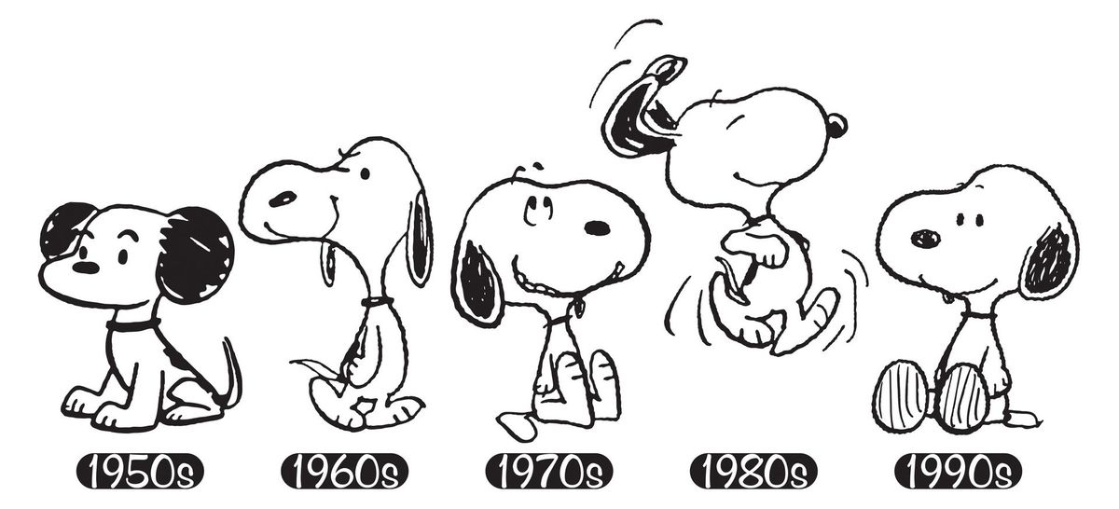
Email: program.intake@usda.gov.

